SONG JOURNEY
"Seven Nation Army"
The White Stripes
Thread song — it appears in all 5 modules
One song, five layers. Each module adds a new skill to this song. Layer 6 is a bonus.
Form Intro/Verse (riff ×4, quiet) → Chorus (same riff, big) → Solo (riff keeps looping)
The riff E · E · G · E · D · C · B — 7 notes, repeats every 2 bars
Rhythm One riff note per beat. 4 beats per bar, 2 bars per cycle.
Key E minor
Tempo Practice at 60 BPM. The record is 123 BPM.
LAYER 1 Listen Module 1
Listen to the song 3 times. This riff (a short musical phrase that repeats) never changes — only the volume around it does.
1. Listen once for the riff.
2. Listen once for the drums.
3. Listen once for how the chorus gets bigger without adding new notes.
Do it: Listen to the song once through.
Count how many times the riff repeats before the first chorus.
You've got it when: You can hum the main riff from memory.
Level up
Listen again. Find the second chorus.
Name one other song built on a short repeating riff.
LAYER 2 Single Notes Module 2
The riff lives on the A string, the one just below the low E string. That is where it sits at true pitch, so it sounds like the record.
The riff · A string · one note per beat
E E G E D C B
e |--------------------|--------------------|
B |--------------------|--------------------|
G |--------------------|--------------------|
D |--------------------|--------------------|
A |--7----7----10---7--|--5----3----2-------|
E |--------------------|--------------------|

Play it: Play one note per beat at 60 BPM, without looking at the chart.
Say each note name out loud as you land it — E · E · G · E · D · C · B.
You've got it when: You can play the riff from memory at 60 BPM.
Level up
Play each riff note 2 times. Then raise the tempo by 10 BPM.
Level up · 2 picks per note · one lap = two bars
e |----------------------|-------------------|
B |----------------------|-------------------|
G |----------------------|-------------------|
D |----------------------|-------------------|
A |-7-7--7-7--10-10--7-7-|-5-5--3-3--2-2-----|
E |----------------------|-------------------|

LAYER 3 Power Chords Module 3
Same riff you played as single notes. Now every root becomes a two-string power chord, one shape sliding along the A string.
Power chords · A string · one chord per riff note
E5 E5 G5 E5 D5 C5 B5
e |--------------------|--------------------|
B |--------------------|--------------------|
G |--------------------|--------------------|
D |--9----9----12---9--|--7----5----4-------|
A |--7----7----10---7--|--5----3----2-------|
E |--------------------|--------------------|

Play it: Play one chord per riff note at 60 BPM, every string ringing clean.
Palm-mute the verse — rest the side of your strumming hand on the strings for a short, muted sound.
Let the strings ring louder in the chorus.
You've got it when: The loop runs at 60 BPM, every string ringing clean, no stops.
Level up
Rest the side of your picking hand on the strings at the bridge. Play 1 lap muted, 1 lap open.
Level up · palm-muted · same chords
E5 E5 G5 E5 D5 C5 B5
e |--------------------|--------------------|
B |--------------------|--------------------|
G |--------------------|--------------------|
D |--9----9----12---9--|--7----5----4-------|
A |--7----7----10---7--|--5----3----2-------|
E |--------------------|--------------------|
PM ──────────────────────────────────────────

LAYER 4 Pentatonic Solo Module 4
The riff is in E minor, so E minor pentatonic fits over every bar. Start with three notes only — Rule of 3 — and leave gaps of silence between notes.
This layer is a ladder with four rungs — each rung is one Module 4 skill. Climb them in order.
Rung 1 · Rule of 3
Three starting notes · E minor pentatonic, open position
E G A
e |----------------------------------|
B |----------------------------------|
G |----------------------------------|
D |----------------------------------|
A |--------------------0-------------|
E |--0---------3---------------------|

Play it: Loop the riff in your head and improvise 4 bars using these 3 notes.
End every phrase on E — that is home, the note the music rests on.
Rung 2 · The whole box
The whole box · E minor pentatonic, open position
e |--0----------3--------------------|
B |--0----------3--------------------|
G |--0-------2-----------------------|
D |--0-------2-----------------------|
A |--0-------2-----------------------|
E |--0----------3--------------------|

Play it: Play the box low to high and back. Then improvise inside it. Land on E.
Rung 3 · Hammer-ons and pull-offs
Hammer-ons and pull-offs · open-position box
D E G A E D E
e |--------------------|--------------------|
B |--------------------|--------------------|
G |------------0h2-----|--------------------|
D |--0h2---------------|--2p0-------2-------|
A |--------------------|--------------------|
E |--------------------|--------------------|

Play it: h = hammer-on, p = pull-off — 2 notes, 1 pick each.
Practice each move slowly until the second note sounds clear. Then add them to your 3-note phrases.
Rung 4 · Two garage-rock licks
Lick 1 · down and back up · lands on E
G E D E
e |--3----0---------0--|
B |------------3-------|
G |--------------------|
D |--------------------|
A |--------------------|
E |--------------------|

Lick 2 · descending · lands on E
A G E
e |--------------------|
B |--------------------|
G |--2----0------------|
D |------------2-------|
A |--------------------|
E |--------------------|

Play it: Learn each lick exactly.
Add the licks to your solos.
You've got it when: You have climbed all 4 rungs — dress-ups and licks show up in your solos.
Level up
Move the same box up 12 frets — same shape, one octave higher, same notes.
This is the higher range used for solos.
The box at fret 12 · E minor pentatonic, one octave up
e |--12----------15--------------------|
B |--12----------15--------------------|
G |--12-------14-----------------------|
D |--12-------14-----------------------|
A |--12-------14-----------------------|
E |--12----------15--------------------|

LAYER 5 Open Chords Module 5
The simple singalong version. The riff's notes become a chord loop you can strum and sing over — a teaching arrangement built from chords you know.
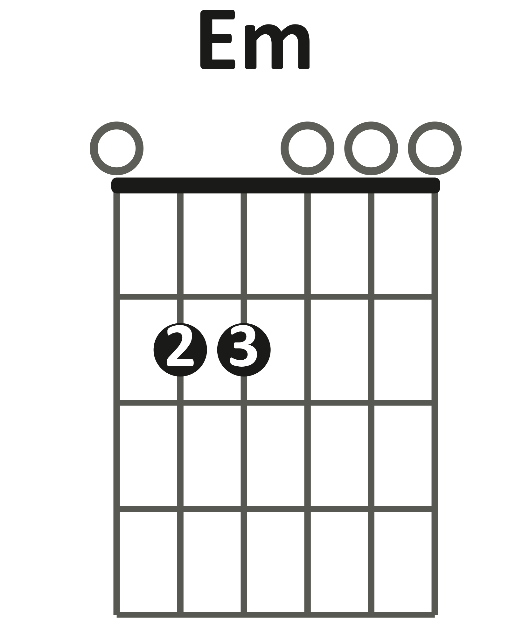 | 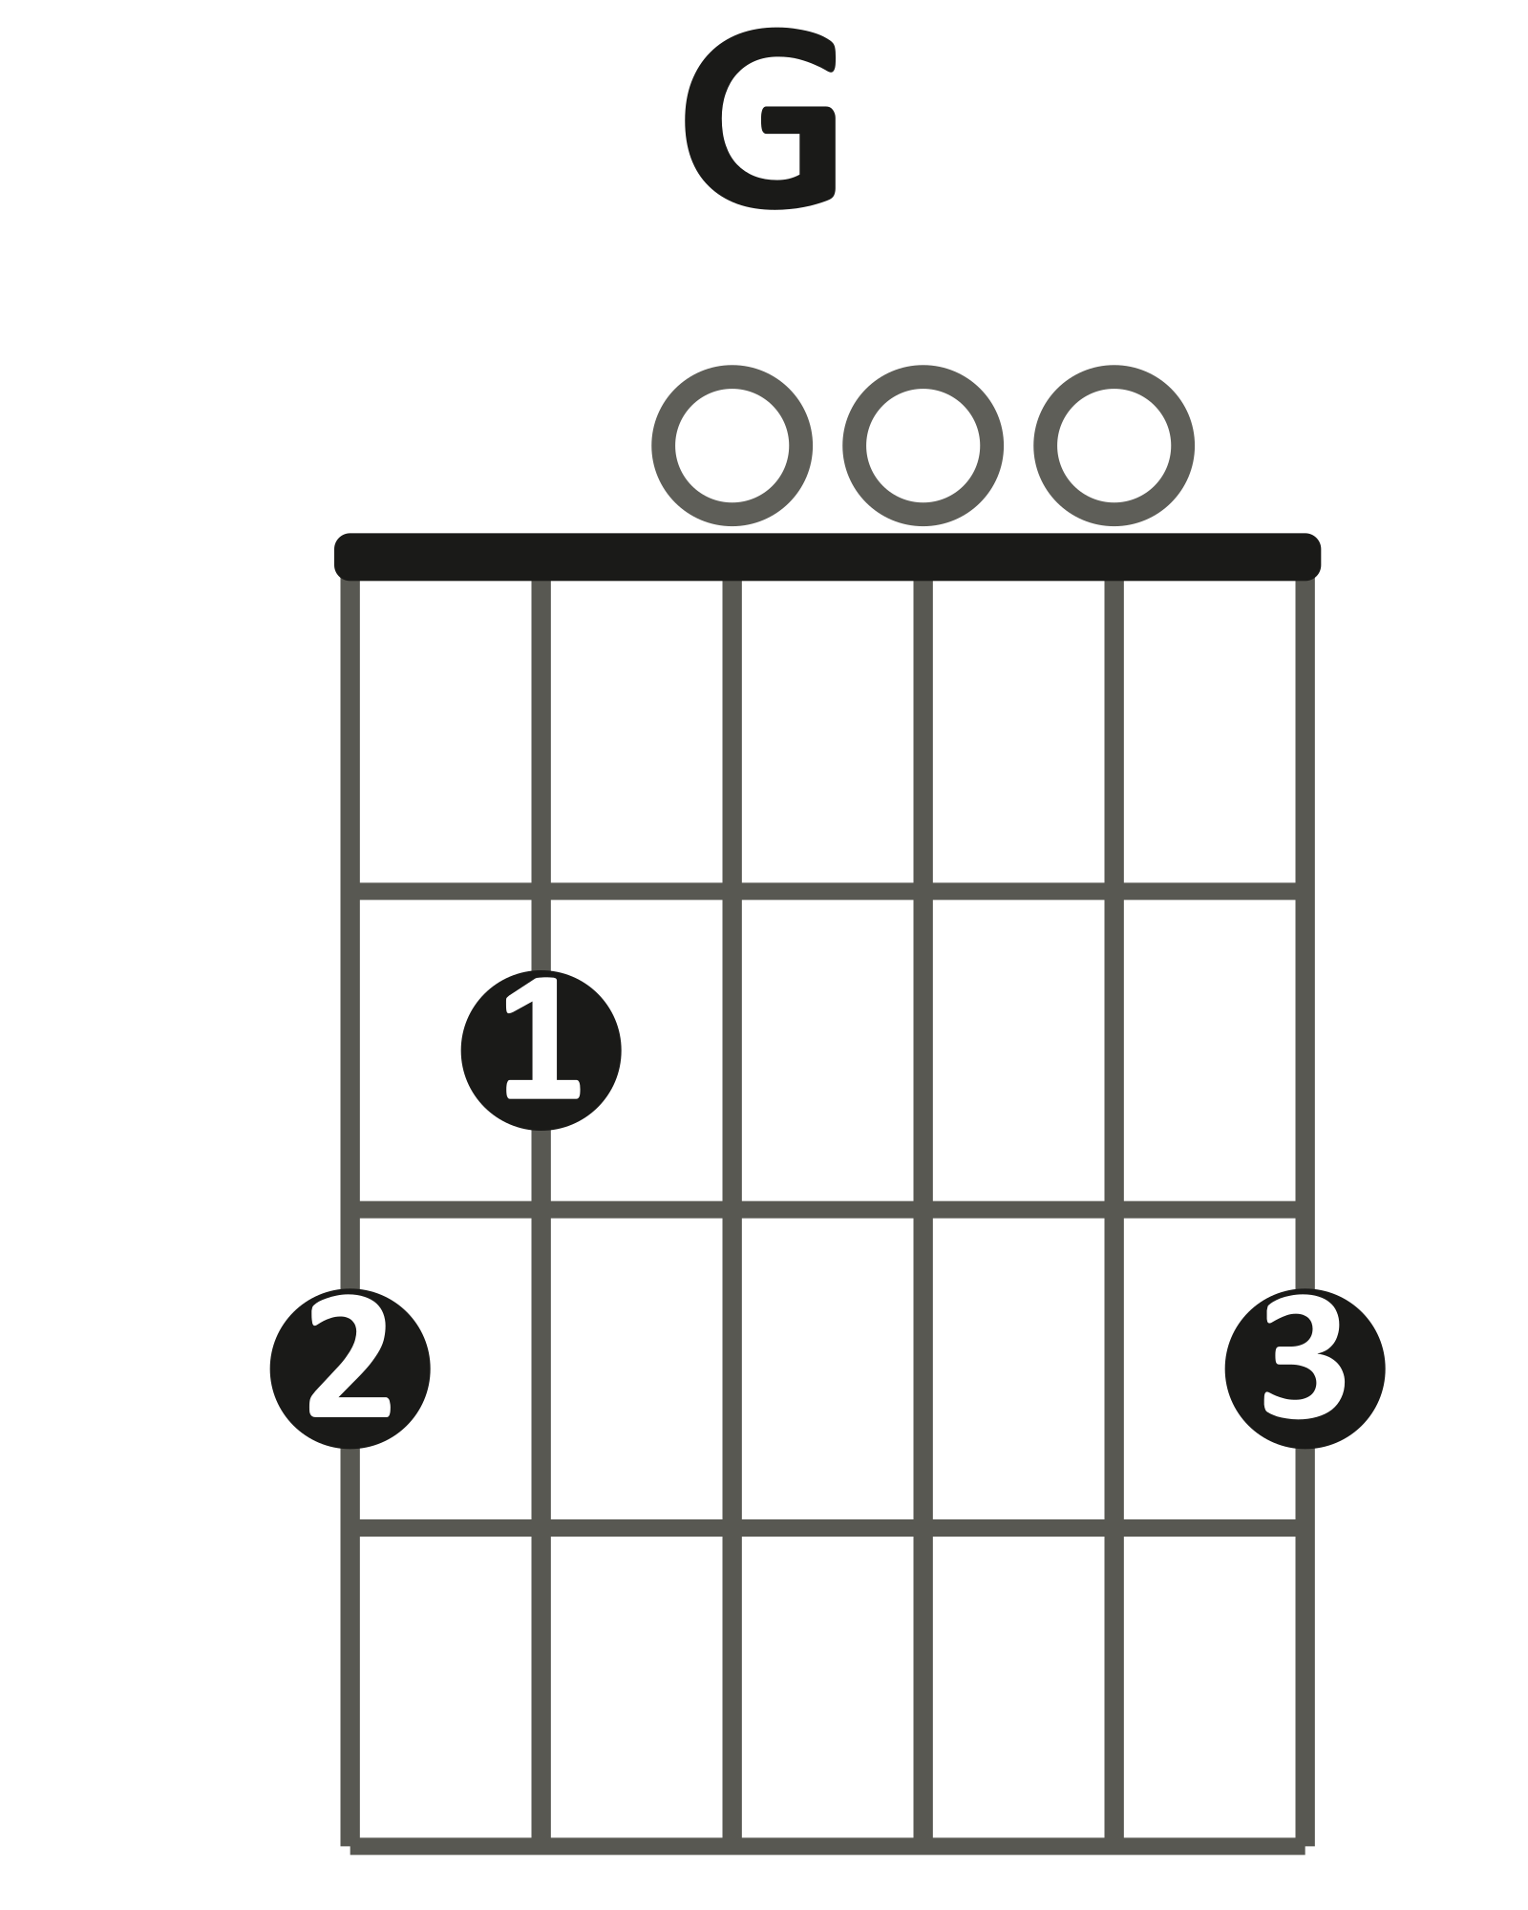 | 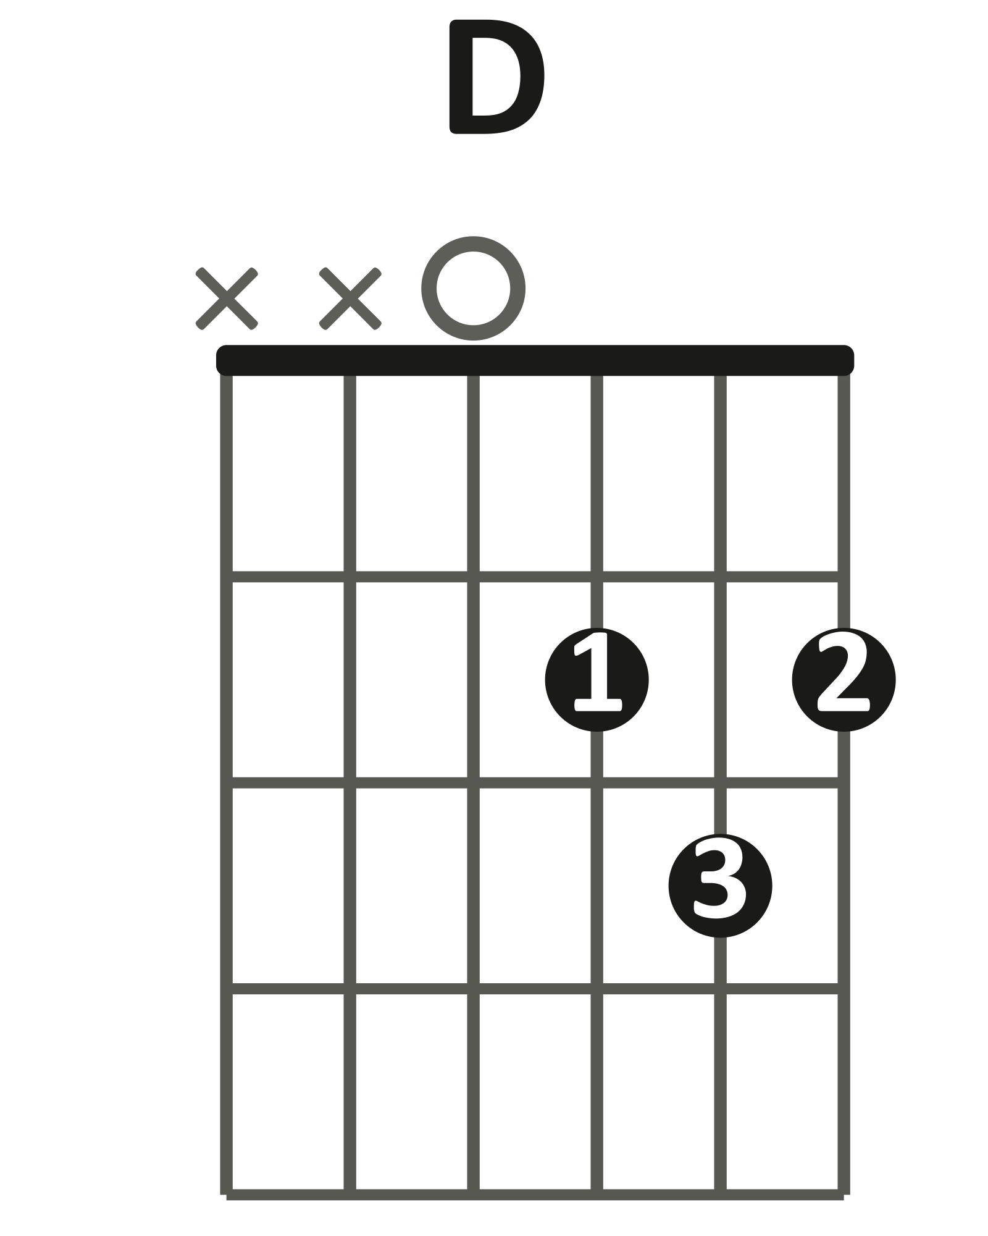 | 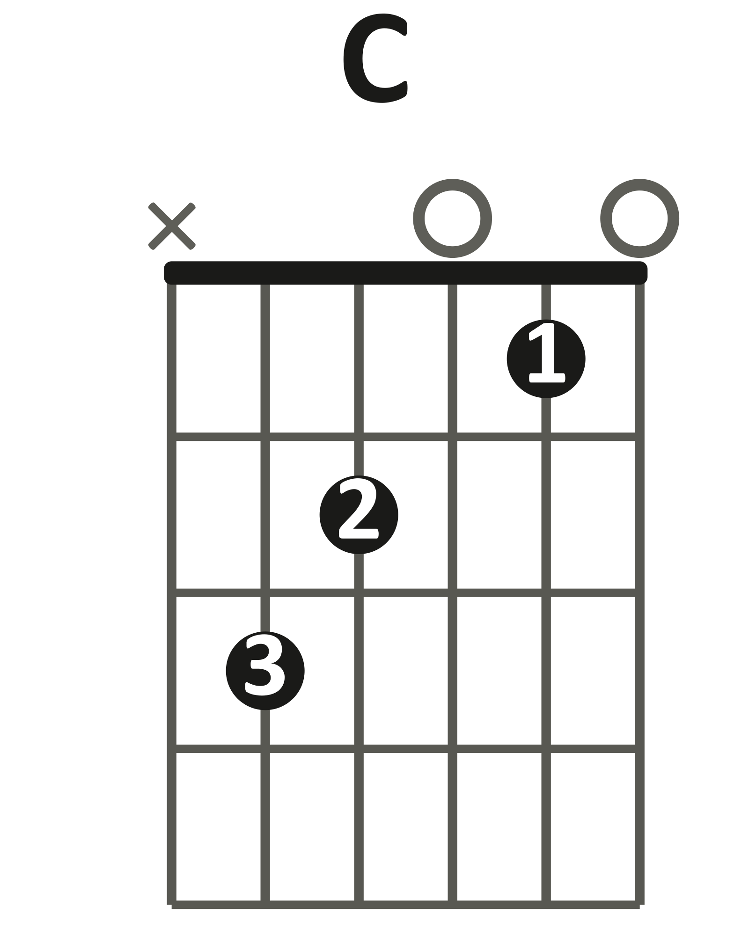

Singalong loop · open chords · one chord per beat
| Em Em G Em | D C C (rest) |
1 2 3 4 1 2 3 4

Play it: Down-strum, one chord per beat.
Land every change on its beat — the same 2-bar cycle as Layers 2 and 3.
Hum the riff while you strum. Same notes, bigger sound.
You've got it when: The full loop runs at 60 BPM with changes on the beat.
Level up
Split strum: D on beats 1 and 3, DU on beats 2 and 4.
Level up · split strum · D on 1 and 3, DU on 2 and 4
| Em Em G Em | D C C – |
1 2 & 3 4 & 1 2 & 3 4
D D U D D U D D U D rest

LAYER 6 The Slide Solo Bonus
Bonus layer. Optional harder challenge. No score. Best once the Layer 2 riff plays from memory.
The slide solo is the Layer 2 riff again, 2 octaves up, played on the high e string with a slide (a metal or glass tube worn on a finger). No slide needed — the frets are your Layer 2 frets plus 5.
The solo · high e string · riff 2 octaves up
E E G E D C B
e |--12---12---15---12-|--10---8----7-------|
B |--------------------|--------------------|
G |--------------------|--------------------|
D |--------------------|--------------------|
A |--------------------|--------------------|
E |--------------------|--------------------|

Play it: Play one note per beat at 60 BPM on the high e string alone.
Play the same pattern 5 frets up: 12 · 12 · 15 · 12, then 10 · 8 · 7.
Slide your finger between frets instead of lifting it.
You've got it when: You can play the solo pattern from memory at 60 BPM, sliding between frets.
Level up
Slide into fret 12 from 2 frets below on each E.
This is the classic slide-guitar entrance.
Level up · slide into the riff · high e string · 2 bars
E E G E D C B
e |--10/12---10/12---15------10/12-|--10------8-------7-------------|
B |--------------------------------|--------------------------------|
G |--------------------------------|--------------------------------|
D |--------------------------------|--------------------------------|
A |--------------------------------|--------------------------------|
E |--------------------------------|--------------------------------|

FULL CHORD CHART
"Seven Nation Army"
The White Stripes
Key E minor
Tempo 123 BPM
Rhythm One chord per riff note — the whole cycle is 2 bars
Form Intro/Verse (riff ×4, quiet) → Chorus (same riff, big) → Solo (riff keeps looping)
Shapes you need

THE RIFF CYCLE
| Em Em G Em | D C C (rest) |
The whole song is this two-bar cycle. Riff notes: E · E · G · E · D · C · B. Beat 4 of bar 2 is a rest.
INTRO / VERSE
(riff cycle ×4)
Quiet. 4 times through the cycle.
CHORUS
(riff cycle, repeat)
Same cycle, big and loud.
SOLO
(riff cycle, repeat)
The riff keeps looping underneath the solo (Bonus layer: the riff 2 octaves up).
Teaching chart — simplified to match the Journey layers, not a note-for-note transcription. Chord names are what the class plays in standard tuning.

